Herschel Data Pipeline

The data set consisted of three parts: the asterisked data (set 1), the unpublished data (set 2), and the published data without set 1 (set 3). Before the data could all be analyzed, the following had to be done:
- Precess coordinates
- Calculate visual ray lengths
- Convert coordinates

Precession involved the Python programming language package Astrolib. Inputting the epoch the coordinates were taken in, the program converted them into both B1950 and J2000 from J1785 for set 2 and J1690 for set 1 & 3. Attached are conversions of various points from both initial epochs, precessed into J2000 and B1950, in addition to the calculated visual ray lengths (Table 1). All original data was given in polar angle. These were all converted to the much more familiar declination.
Herschel gave two methods of calculating visual ray lengths (in units of Sirius distances) based on two similar geometries. The first (Equation 1-2) relied on a geometry Herschel was able to convey much more clearly. Herschel gave ray lengths calculated using both methods for a single point of data, which differed by 34 ray units (498 RU for the first method, 464 RU for the second).

Equation 1

Equation 2

Where D was the visual ray length, and S was the average stars per region of sky.
The last part consisted of converting units for use in various plots. The precession to B1950 was in order to use the data in galactic coordinate plots, which were also handled by the program. Additionally, the data was converted into rectangular coordinates, with the XY plane represented by the plane of 0 declination, and Z parallel to Earth's poles. Attached are various points in galactic coordinates, and a sample plot (Table 2, Figure 1-2).

Lastly, the rectangular coordinates of the data sets were converted and imported into engineering modeling software, SolidWorks, where the full data set was split into slices of 50. The slice was then made 3-dimensional by extending both sides to the data points furthest from the central plane. The size of the resultant thick slice was then directly related to the density of points in a region: the thicker the slice, the more disperse the points were and vice-versa. A preliminary model was finally printed on the 3D printer in Gerald Seidler's x-ray spectroscopy lab.

Table 1

Table 2

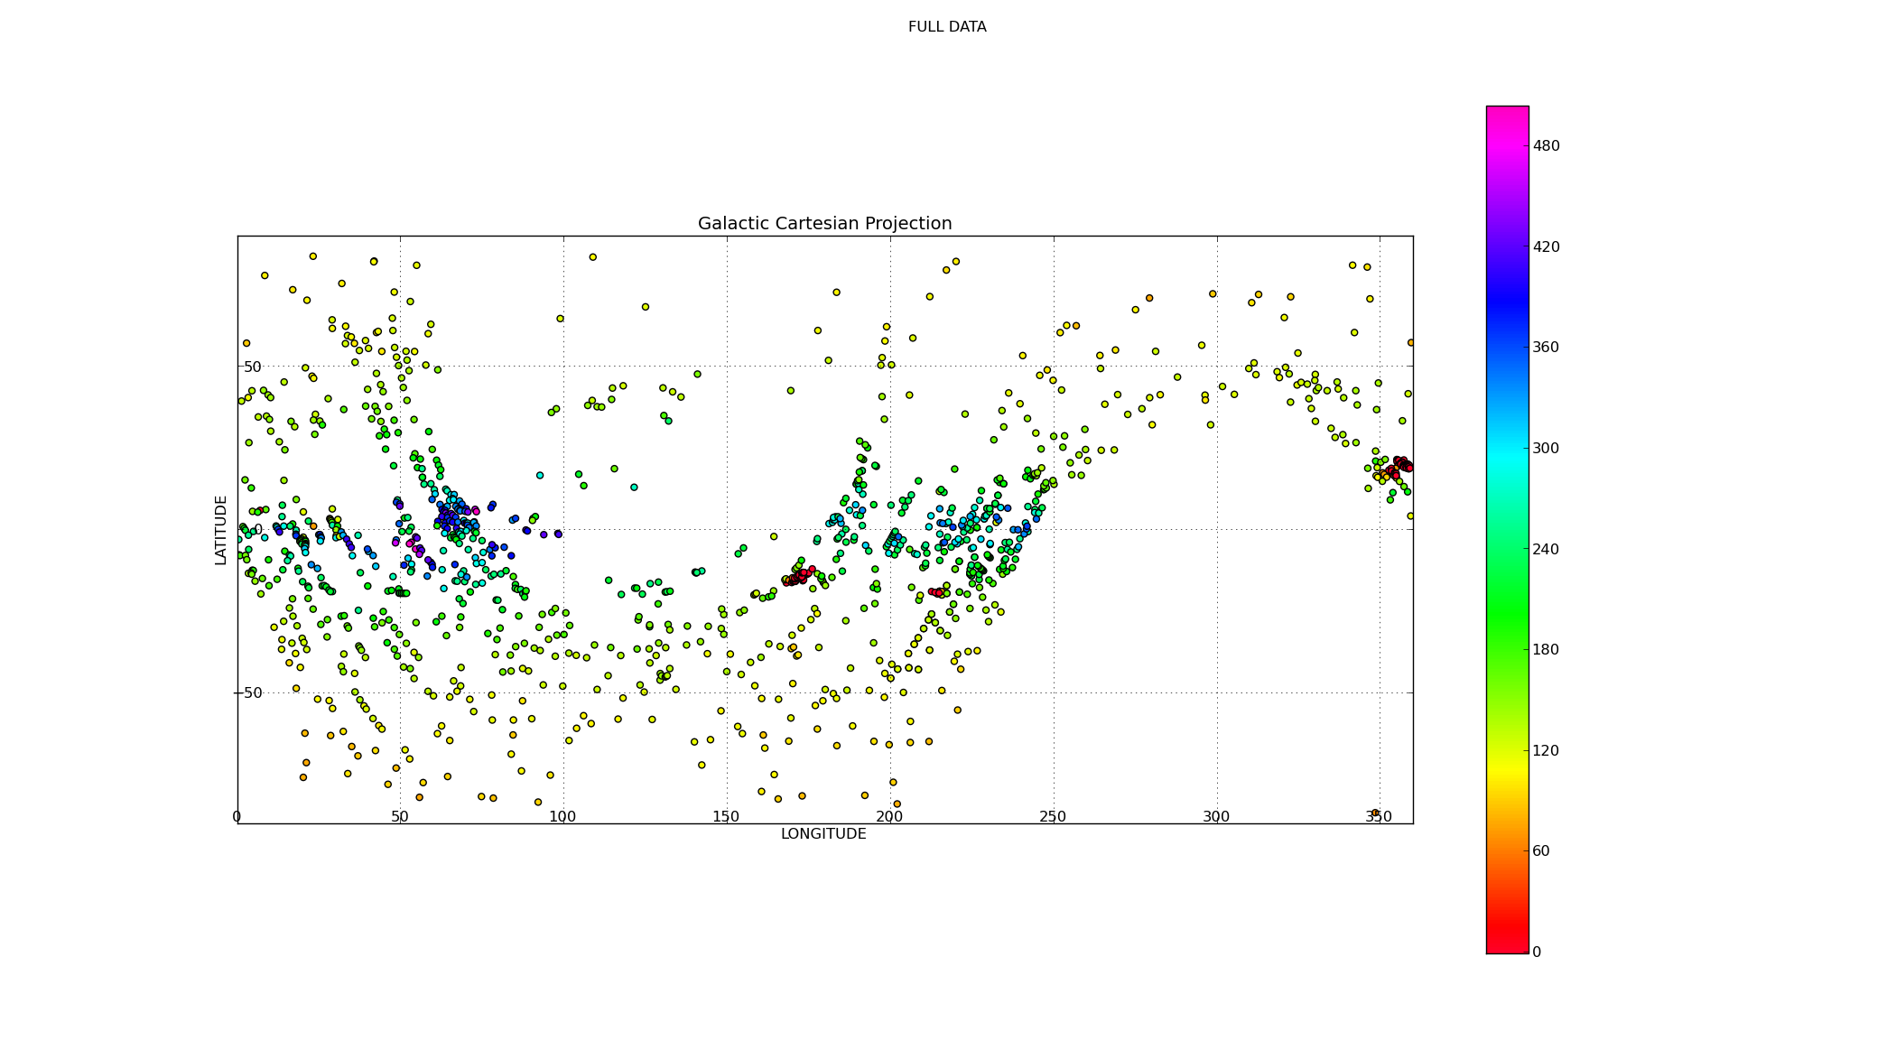
Figure 1

